# Programming solving problems:

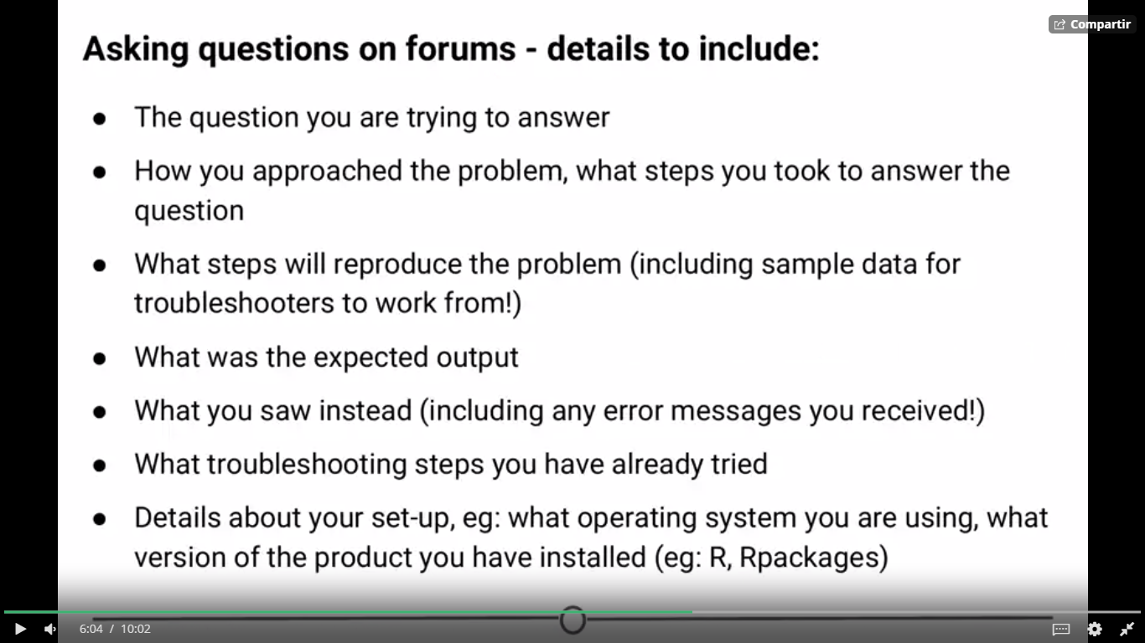

**How to put titles in R**

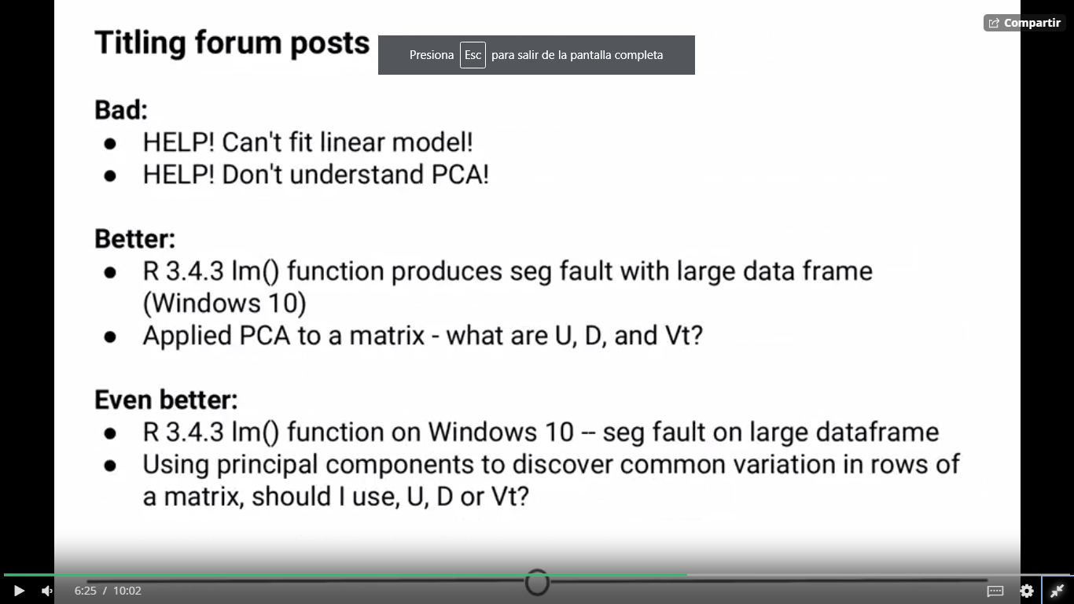

**Ambiente de RStudio**

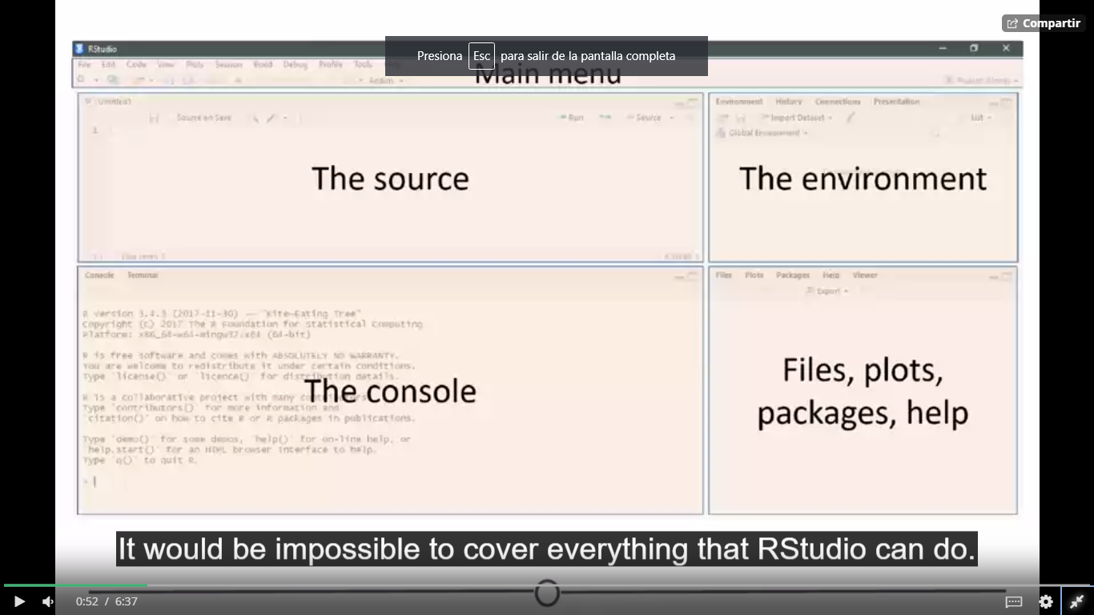

**R menus**

**Session menu**

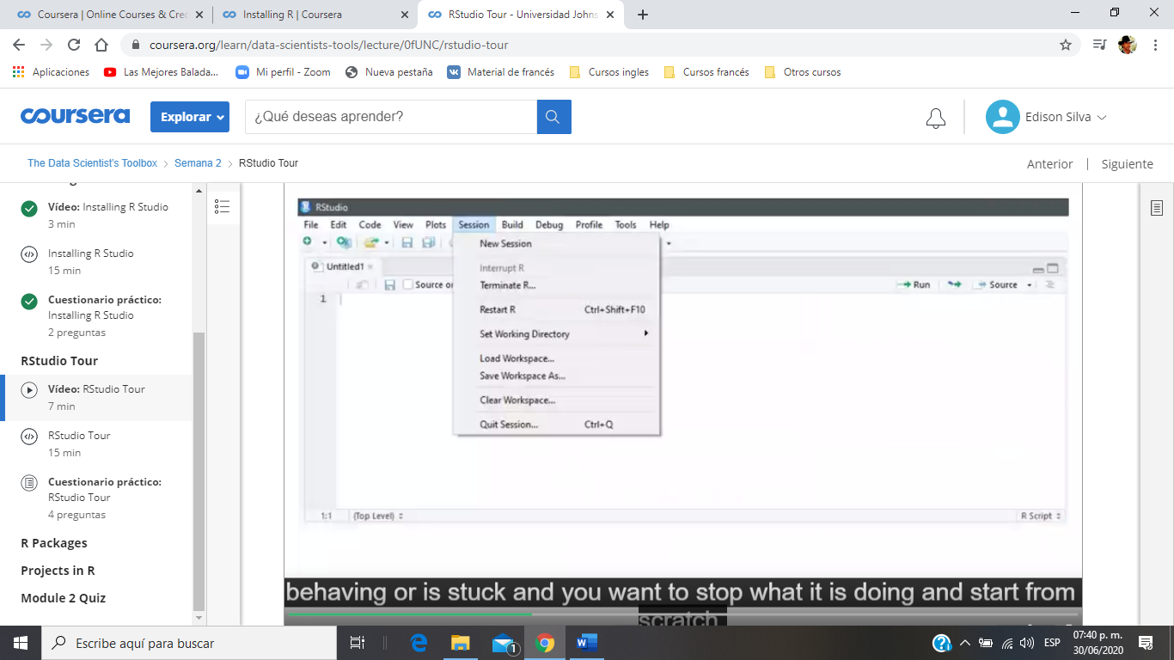

Terminate command is useful when the program gets stucked and it stops what you’re doing and starts from the scratch

**Console**

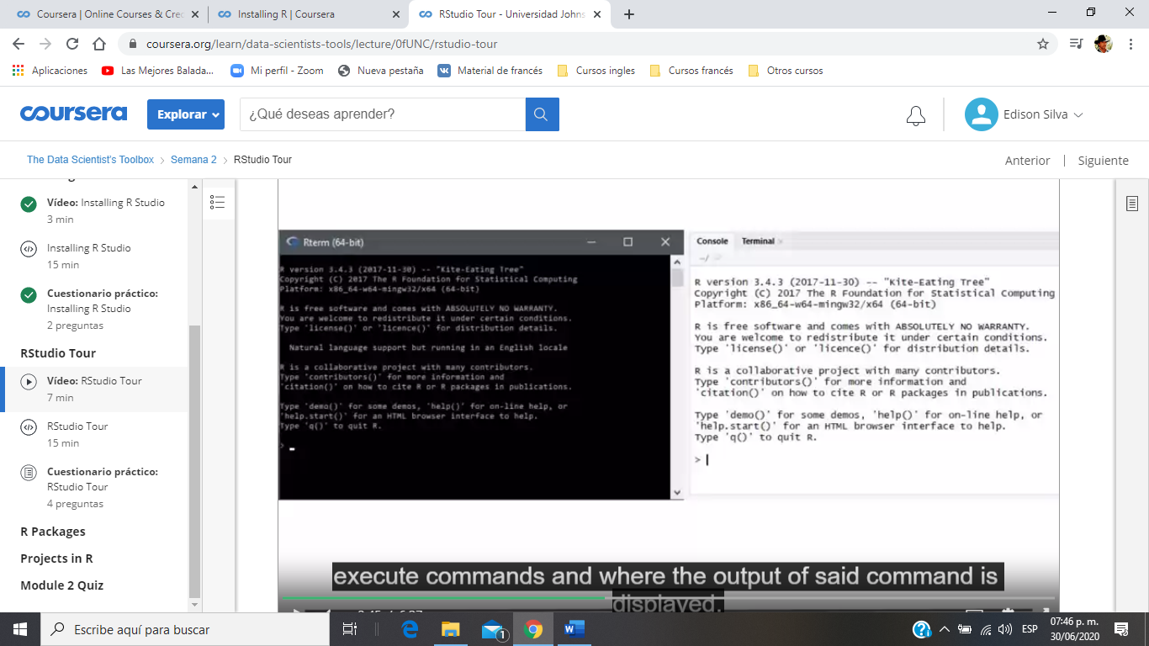

There you can type in execute commands and where the output of said command is displayed.

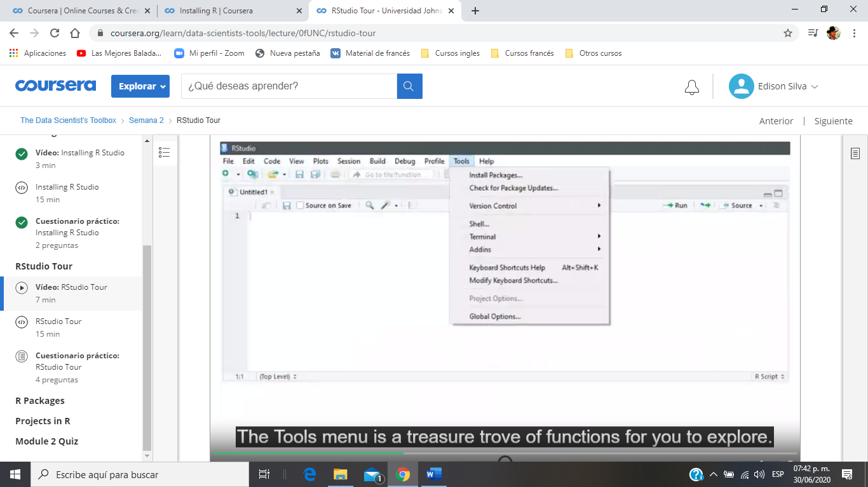

There you can go to install new packages, see your next lecture, set up your version control software, see future lesson and set your preferences for how Rstudio looks and functions.

**The environment quadrant**

Click anywhere on the “example” line, and a new tab on the Source quadrant should appear, showing the matrix you created. Any dataframe or matrix that you create in R can be viewed this way in RStudio.

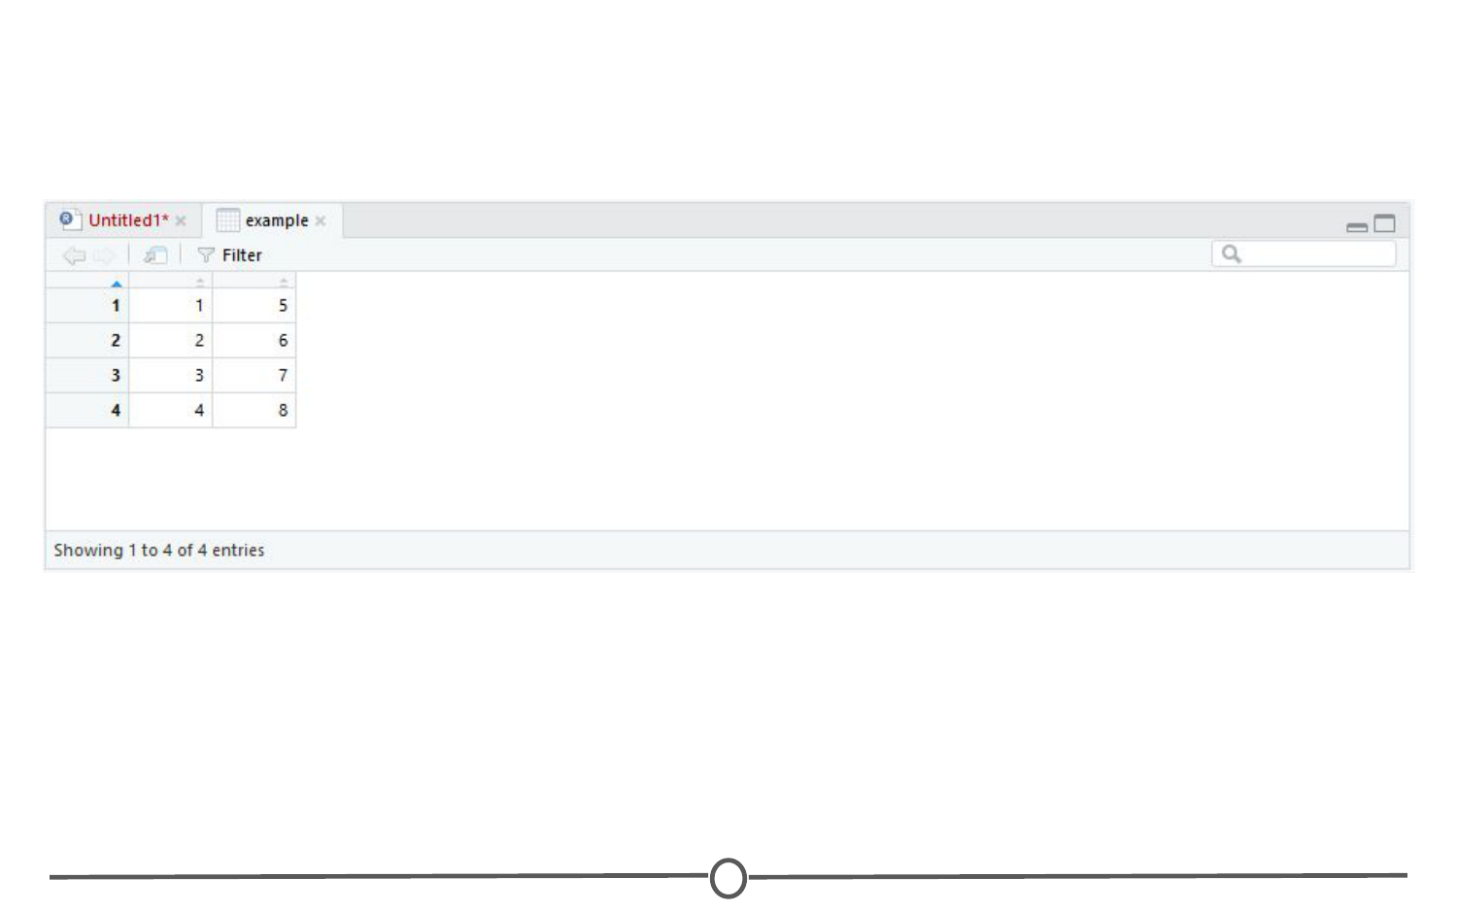

The quadrant has two other tabs running across the top of it. We’ll just look at the History tab now. Your history tab should look something like this:

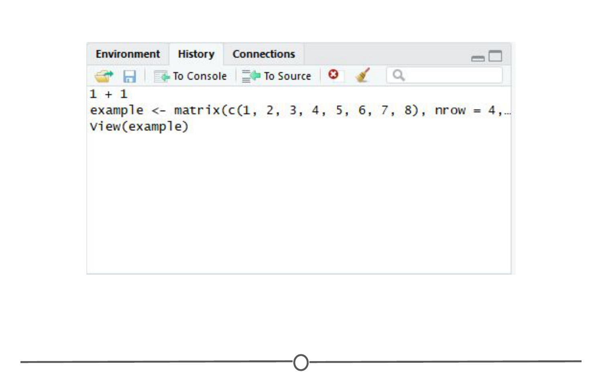

**The history tab**

Here you will see the commands that we have run in this session of R. If you click on any one of them, you can click “To Console” or “To Source” and this will either rerun the command in the console, or will move the command to the source, respectively. Do so now for your example matrix and send it to Source.

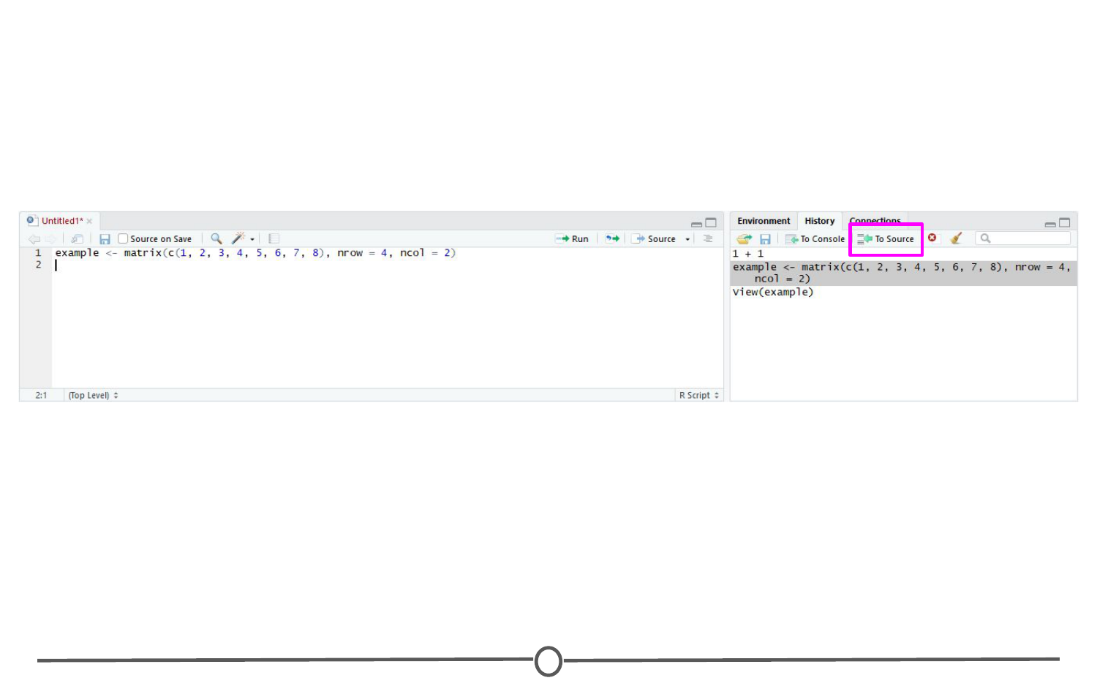

What are repositories?

A repository is a central location where many developed packages are located and available for download.

There are three big repositories:  
1. [**CRAN (Comprehensive R Archive Network):**](https://cran.r-project.org/web/packages/) R’s main repository (>12,100 packages available!)  
2. [**BioConductor:**](https://bioconductor.org/packages/release/BiocViews.html#___Software) A repository mainly for bioinformatic-focused packages  
3. [**GitHub:**](https://github.com/collections) A very popular, open source repository (not R specific!)

Take a second to explore the links above and check out the various packages that are out there!

How do you know what package is right for you?

First, CRAN groups all of its packages by their functionality/topic into 35 “themes.” It calls this its “Task view.” This at least allows you to narrow the packages you can look through to a topic relevant to your interests.

Also, there is a great website, RDocumentation, which is a search engine for packages and functions from CRAN, BioConductor, and GitHub (ie: the big three repositories. It also has a “task” view like CRAN, that allows you to browse themes.

How do you install packages?

**Installing from CRAN:**

If you are installing from the CRAN repository, use the install.packages() function, with the name of the package you want to install in quotes between the parentheses (note: you can use either single or double quotes). For example, if you want to install the package “ggplot2”, you would use: install.packages("ggplot2")

Try doing so in your R console! This command downloads the “ggplot2” package from CRAN and installs it onto your computer.

If you want to install multiple packages at once, you can do so by using a character vector, like: install.packages(c("ggplot2", "devtools", "lme4"))

If you want to use RStudio’s graphical interface to install packages, go to the Tools menu, and the first option should be “Install packages…” If installing from CRAN, select it as the repository and type the desired packages in the appropriate box.

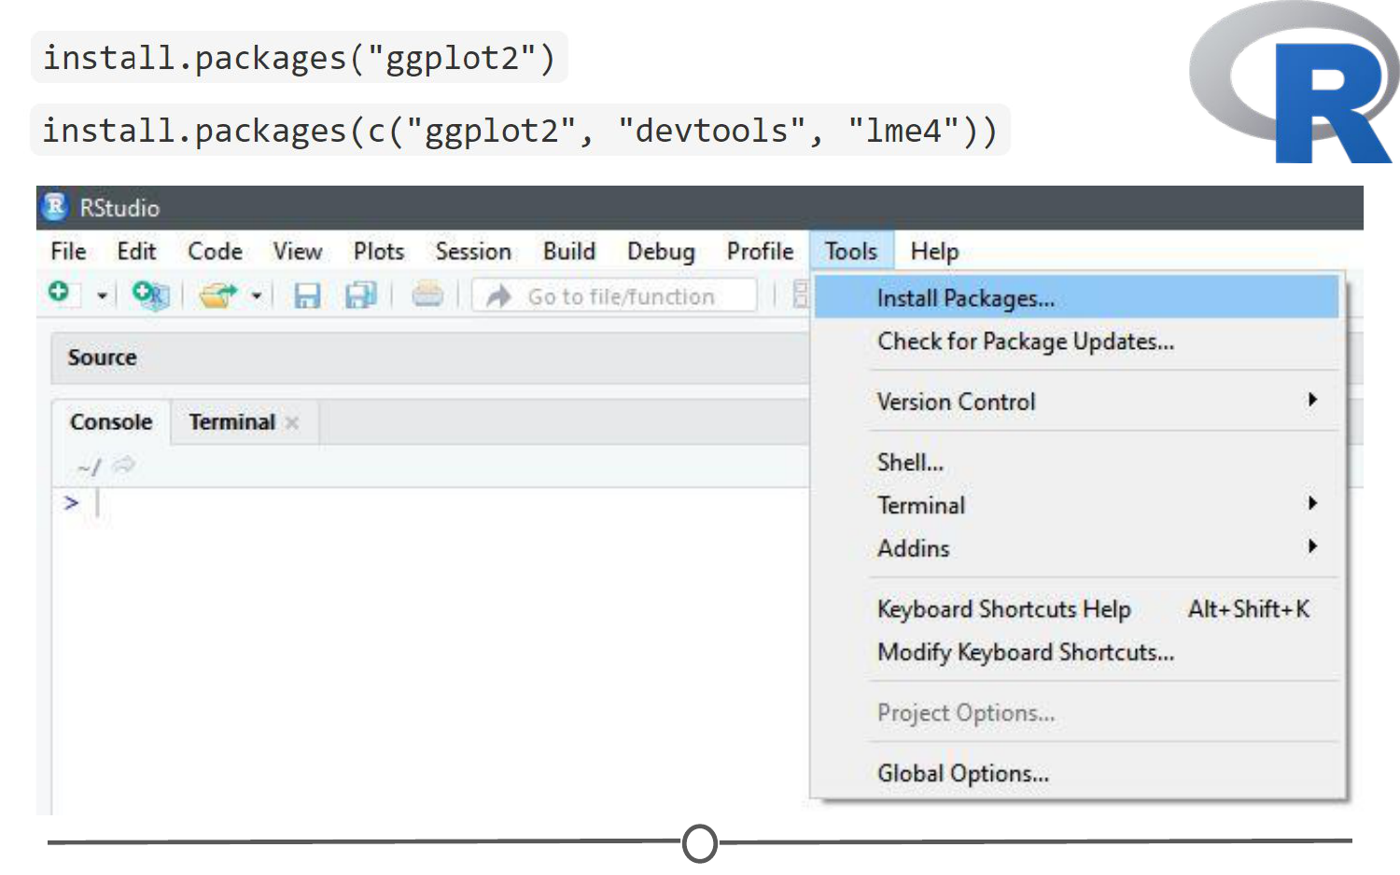

**Installing from Bioconductor**

The BioConductor repository uses their own method to install packages. First, to get the basic functions required to install through BioConductor, use: source("https://bioconductor.org/biocLite.R")

This makes the main install function of BioConductor, biocLite(), available to you. Following this, you call the package you want to install in quotes, between the parentheses of the biocLite command, like so: biocLite("GenomicFeatures")

**Installing from GitHub**  
This is a more specific case that you probably won’t run into too often. You first must find the package you want on GitHub and take note of both the package name AND the author of the package. Check out [this guide](http://kbroman.org/pkg_primer/pages/github.html) for installing from GitHub, but the general workflow is:

1. install.packages("devtools") - only run this if you don’t already have devtools installed. If you’ve been following along with this lesson, you may have installed it when we were practicing installations using the R console
2. library(devtools) - more on what this command is doing immediately below this
3. install_github("author/package") replacing “author” and “package” with their GitHub username and the name of the package.

Loading packages

Installing a package does not make its functions immediately available to you. First you must **load** the package into R; to do so, use the library() function. You’ve installed it, but now you have to “open” it. For example, to “open” the “ggplot2” package, you would run:

library(ggplot2)

**NOTE:** Do **not** put the package name in quotes!

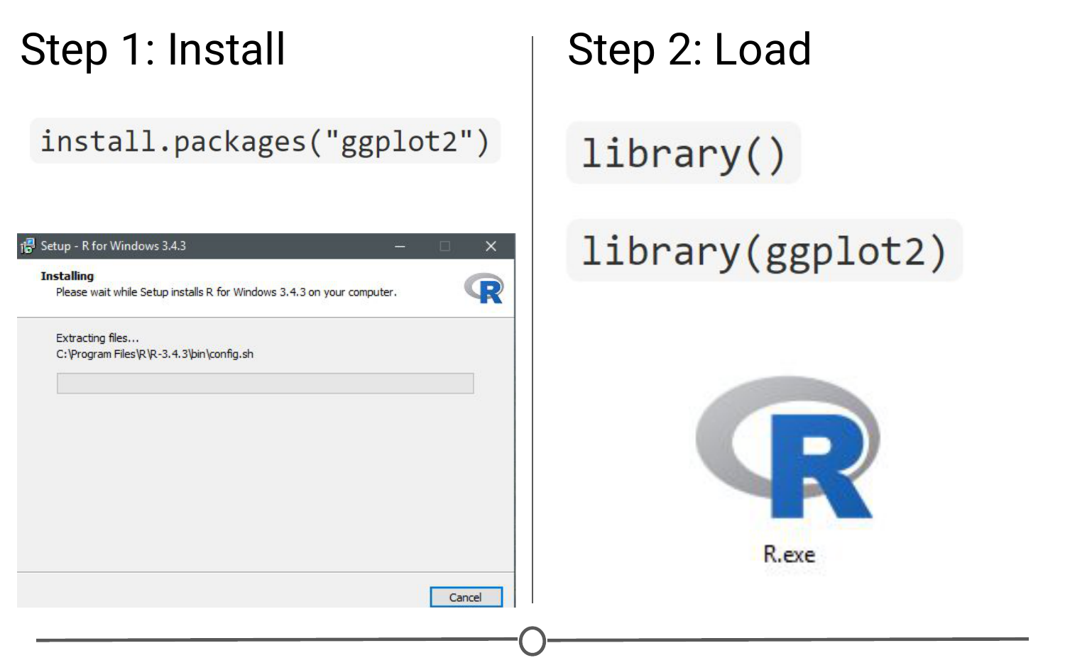

If you want to load a package using the RStudio interface, in the lower right quadrant there is a tab called “Packages” that lists out all of the packages and a brief description, as well as the version number, of all of the packages you have installed. To load a package just click on the checkbox beside the package name

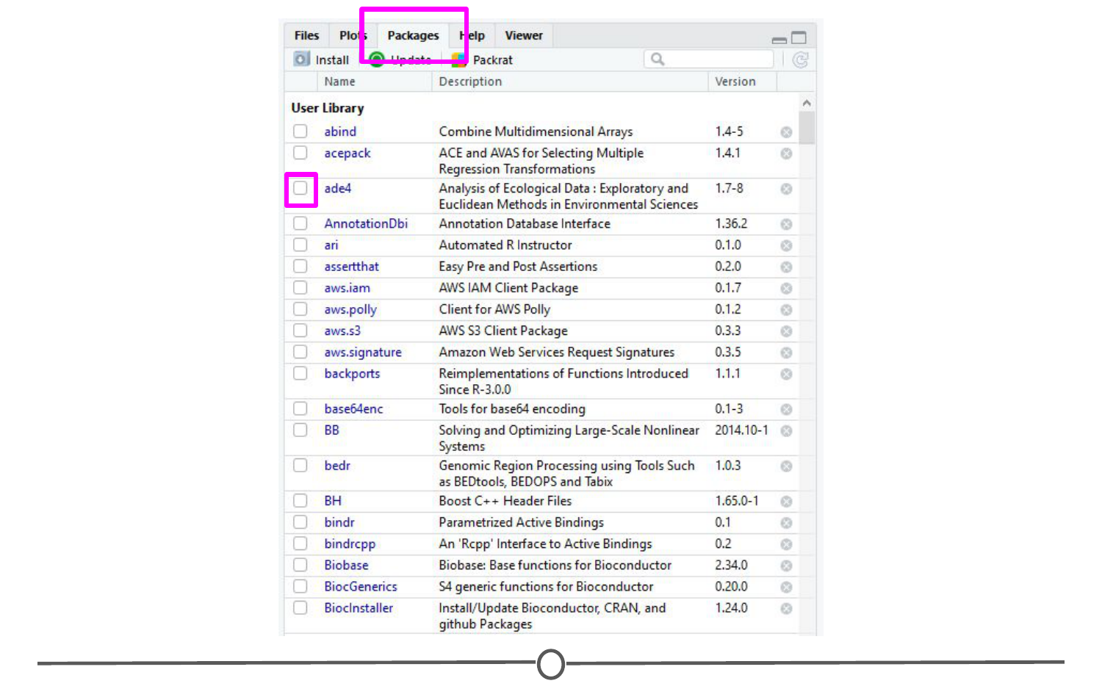

Updating, removing, unloading packages

**Checking what packages you have installed**

If you aren’t sure if you’ve already installed a package, or want to check what packages are installed, you can use either of: installed.packages() or library() with nothing between the parentheses to check!

**Updating packages**

You can check what packages need an update with a call to the function old.packages() This will identify all packages that have been updated since you installed them/last updated them.

To update all packages, use update.packages().

If you only want to update a specific package, just use once

again install.packages("packagename")

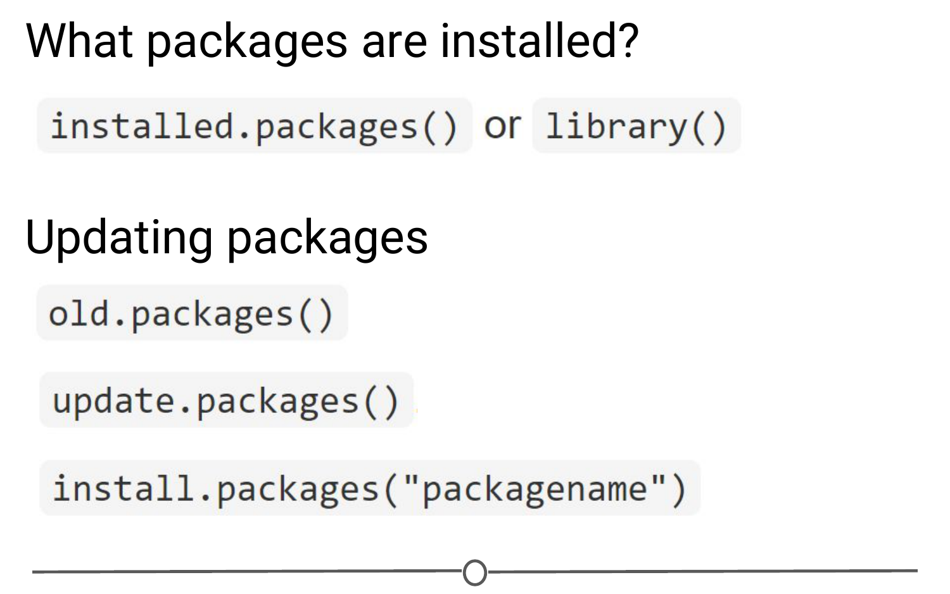

**Functions used to see what packages are installed and update them**

Within the RStudio interface, still in that Packages tab, you can click “Update,” which will list all of the packages that are not up to date. It gives you the option to update all of your packages, or allows you to select specific packages.

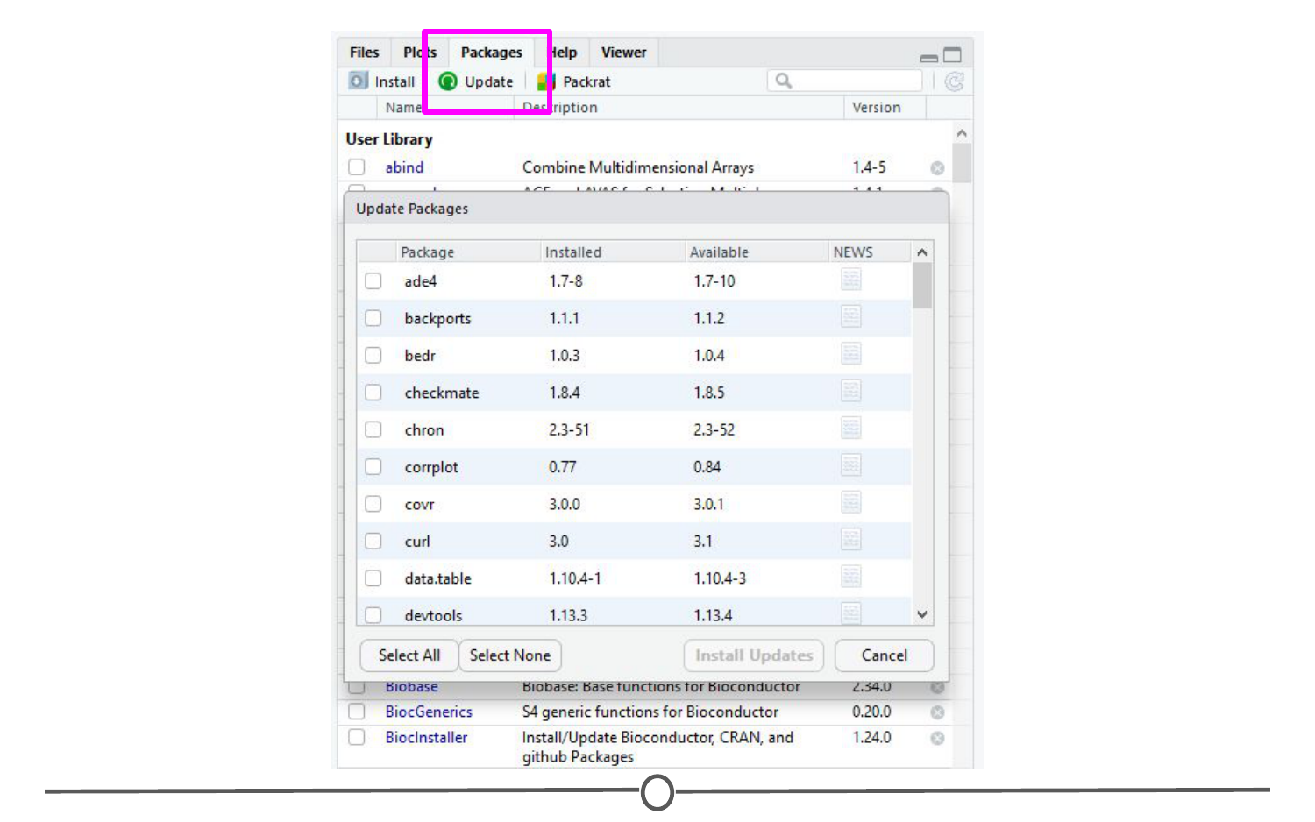

**Unloading packages**

Sometimes you want to unload a package in the middle of a script - the package you have loaded may not play nicely with another package you want to use.

To unload a given package you can use the detach() function. For example, detach("package:ggplot2", unload=TRUE) would unload the ggplot2 package (that we loaded earlier). Within the RStudio interface, in the Packages tab, you can simply unload a package by unchecking the box beside the package name.

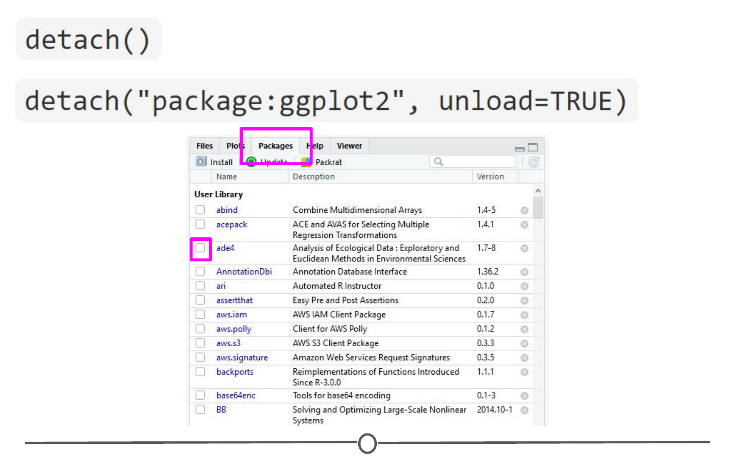

**Uninstalling packages**

If you no longer want to have a package installed, you can simply uninstall it using the function remove.packages(). For example, remove.packages("ggplot2")

Within RStudio, in the Packages tab, clicking on the “X” at the end of a package’s row will uninstall that package.

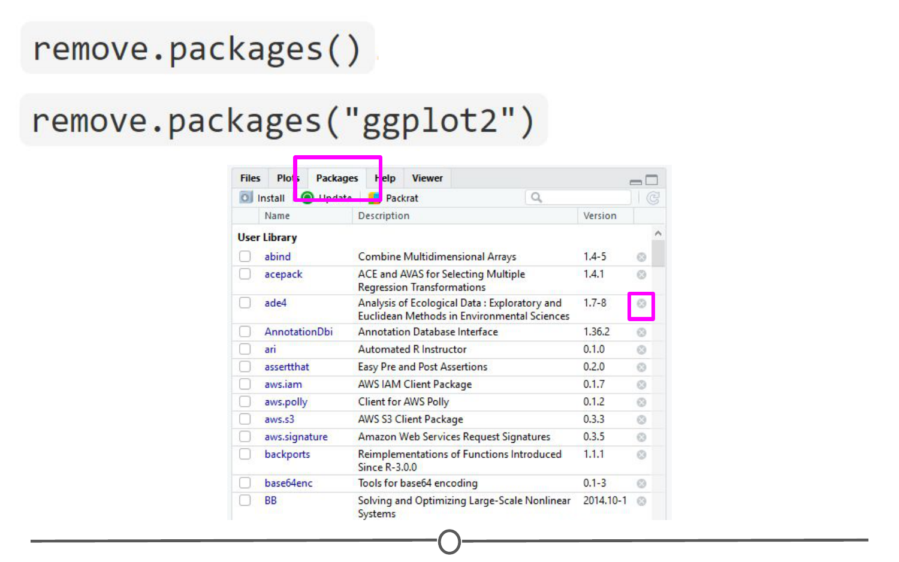

**How do you know what version of R you have?**

Sometimes, when you are looking at a package that you might want to install, you will see that it requires a certain version of R to run.

One way to know your R version is to check when you first open R/RStudio - the first thing it outputs in the console tells you what version of R is currently running. If you didn’t pay attention at the beginning, you can type version into the console and it will output information on the R version you are running. Another helpful command is sessionInfo() - it will tell you what version of R you are running along with a listing of all of the packages you have loaded.

The output of this command is a great detail to include when posting a question to forums - it tells potential helpers a lot of information about your OS, R, and the packages (plus their version numbers!) that you are using.

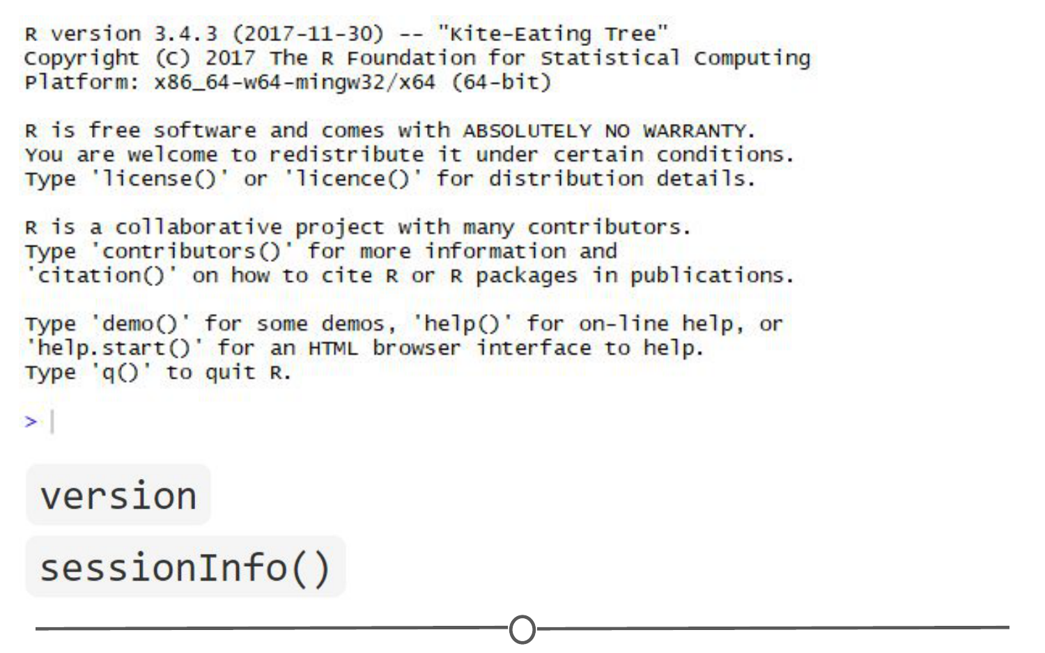

Using the commands in a function

In all of this information about packages, we haven’t actually discussed how to *use* a package’s functions!

First, you need to know what functions are included within a package. To do this, you can look at the man/help pages included in all (well-made) packages. In the console, you can use the help() function to access a package’s help files. Try help(package = "ggplot2") and you will see all of the *many* functions that ggplot2 provides. Within the RStudio interface, you can access the help files through the Packages tab (again) - clicking on any package name should open up the associated help files in the “Help” tab, found in that same quadrant, beside the Packages tab.

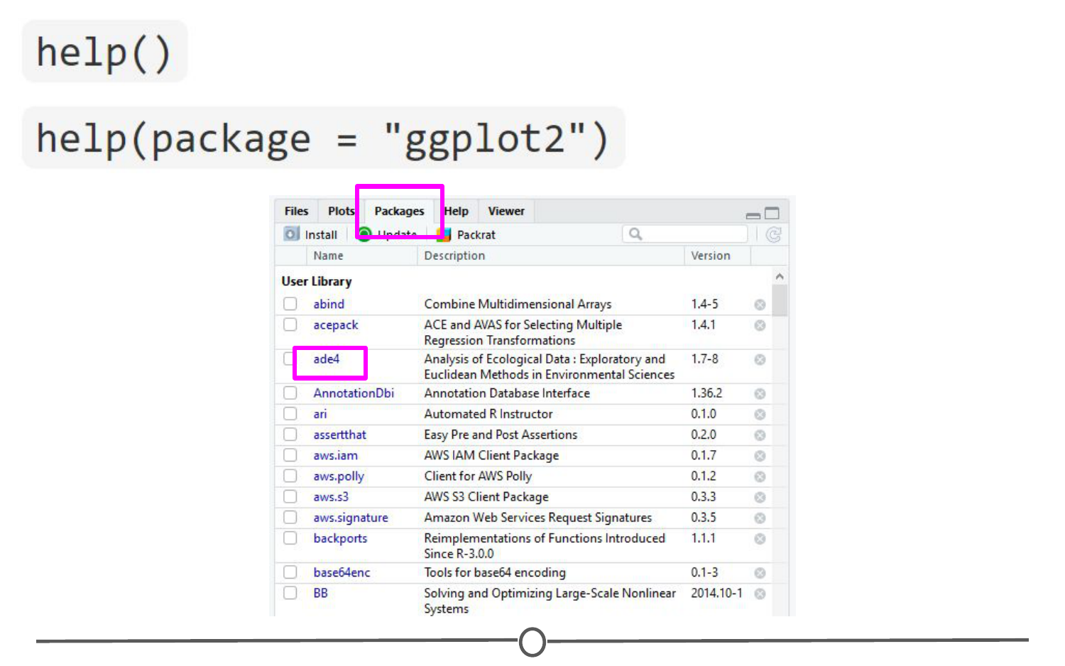

If you still have questions about what functions within a package are right for you or how to use them, many packages include **“vignettes.”** These are extended help files, that include an overview of the package and its functions, but often they go the extra mile and include detailed examples of how to use the functions in plain words that you can follow along with to see how to use the package. To see the vignettes included in a package, you can use the browseVignettes() function. For example, let’s look at the vignettes included in ggplot2:browseVignettes("ggplot2") . You should see that there are two included vignettes: “Extending ggplot2” and “Aesthetic specifications.” Exploring the Aesthetic specifications vignette is a great example of how vignettes can be helpful, clear instructions on how to use the included functions.

